### Final Exam Java

Author: Qingjun Bao

Date: 2022-07-28

**Source Code**



**Screenshot**

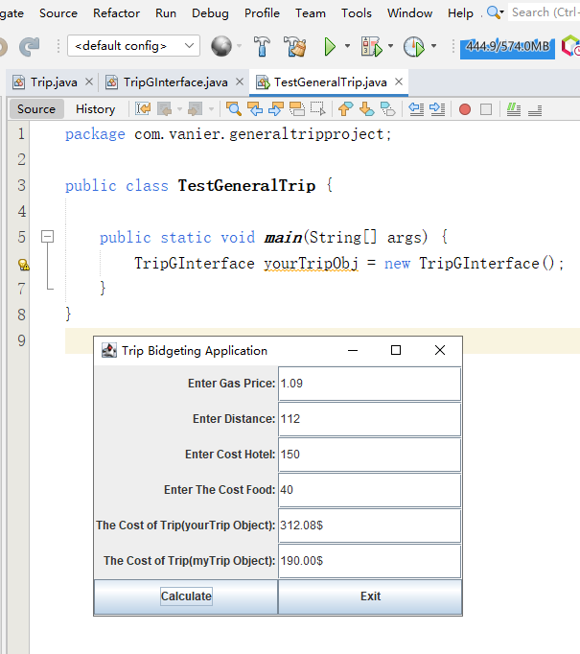

**TestGeneralTrip.java**

1. **package** com.vanier.generaltripproject;
3. **public** **class** TestGeneralTrip {
5. **public** **static** **void** main(String[] args) {
6. TripGInterface yourTripObj = **new** TripGInterface();
7. }
8. }

**Trip.java**

1. **package** com.vanier.generaltripproject;
3. **public** **class** Trip {
4. **private** **double** cost_trip;
6. **private** **double** gas_price;
7. **private** **int** distance;
8. **private** **int** cost_hotel;
9. **private** **int** cost_food;
11. Trip(){};
13. Trip(**double** u_gas_price, **int** u_distance, **int** u_cost_hotel, **int** u_cost_food){
14. gas_price = u_gas_price;
15. distance = u_distance;
16. cost_hotel = u_cost_hotel;
17. cost_food = u_cost_food;
18. };
20. **public** **double** CalculateCostTrip() {
21. cost_trip = (distance * gas_price) + cost_hotel + cost_food;
22. **return** cost_trip;
23. }
25. **public** **void** setGasPrice(**double** u_gas_price) {
26. gas_price = u_gas_price;
27. }
29. **public** **void** setDistance(**int** u_distance) {
30. distance = u_distance;
31. }
33. **public** **void** setCostHotel(**int** u_cost_hotel) {
34. cost_hotel = u_cost_hotel;
35. }
37. **public** **void** setCostFood(**int** u_cost_food) {
38. cost_food = u_cost_food;
39. }
41. **public** **double** getGasPrice() {
42. **return** gas_price;
43. }
45. **public** **int** getDistance() {
46. **return** distance;
47. }
49. **public** **int** getCostHotel() {
50. **return** cost_hotel;
51. }
53. **public** **int** getCostFood() {
54. **return** cost_food;
55. }
56. }

**TripGInterface.java**

1. **package** com.vanier.generaltripproject;
2. **import** javax.swing.*;
3. **import** java.awt.*;
4. **import** java.awt.event.*;
5. **public** **class** TripGInterface **extends** JFrame **implements** ActionListener {
6. JTextField u_gas_priceTF, u_distanceTF, u_cost_hotelTF, u_cost_foodTF;
7. JTextField u_cost_yourTripTF, u_cost_myTripTF;
8. **public** TripGInterface() {
9. //Create the 6 labels
10. JLabel u_gas_price = **new** JLabel("Enter Gas Price: ", SwingConstants.RIGHT);
11. JLabel u_distance = **new** JLabel("Enter Distance: ", SwingConstants.RIGHT);
12. JLabel u_cost_hotel = **new** JLabel("Enter Cost Hotel: ", SwingConstants.RIGHT);
13. JLabel u_cost_food = **new** JLabel("Enter The Cost Food: ", SwingConstants.RIGHT);
14. JLabel u_cost_yourTrip = **new** JLabel("The Cost of Trip(yourTrip Object): ", SwingConstants.RIGHT);
15. JLabel u_cost_myTrip = **new** JLabel("The Cost of Trip(myTrip Object): ", SwingConstants.RIGHT);
17. //Create the 6 text fields
18. u_gas_priceTF = **new** JTextField(10);
19. u_distanceTF = **new** JTextField(10);
20. u_cost_hotelTF = **new** JTextField(10);
21. u_cost_foodTF = **new** JTextField(10);
22. u_cost_yourTripTF = **new** JTextField(10);
23. u_cost_myTripTF = **new** JTextField(10);
25. //Create Calculate Button
26. JButton calculateB = **new** JButton("Calculate");
28. //Associate or register this listener with the corresponding JButton
29. calculateB.addActionListener(**this**);
31. //Create Exit Buttonthis
32. JButton exitB = **new** JButton("Exit");
33. //Associate or register this listener with the corresponding JButton
34. exitB.addActionListener(**this**);
36. //Set the title of the window
37. setTitle("Trip Bidgeting Application");
39. //Get the container
40. Container pane = getContentPane();
42. //Set the layout
43. pane.setLayout(**new** GridLayout(7, 2));
45. //Place the components in the pane
46. pane.add(u_gas_price);
47. pane.add(u_gas_priceTF);
49. pane.add(u_distance);
50. pane.add(u_distanceTF);
52. pane.add(u_cost_hotel);
53. pane.add(u_cost_hotelTF);
55. pane.add(u_cost_food);
56. pane.add(u_cost_foodTF);
58. pane.add(u_cost_yourTrip);
59. pane.add(u_cost_yourTripTF);
61. pane.add(u_cost_myTrip);
62. pane.add(u_cost_myTripTF);
64. pane.add(calculateB);
65. pane.add(exitB);
67. //Set the size of the window and display it
68. setSize(400, 300);
69. setVisible(**true**);
70. }
72. **public** **void** actionPerformed(ActionEvent e) {
73. **if**(e.getActionCommand().equals("Calculate")) {
74. **double** u_gas_priceInput, u_CostHourInput;
75. **int** u_distanceInput, u_cost_hotelInput, u_cost_foodInput;
76. **double** u_cost_yourTripOutput, u_cost_myTripOutput;
78. u_gas_priceInput = Double.parseDouble(u_gas_priceTF.getText());
79. u_distanceInput = Integer.parseInt(u_distanceTF.getText());
80. u_cost_hotelInput = Integer.parseInt(u_cost_hotelTF.getText());
81. u_cost_foodInput = Integer.parseInt(u_cost_foodTF.getText());
83. Trip yourTrip = **new** Trip();
85. yourTrip.setGasPrice(u_gas_priceInput);
86. yourTrip.setDistance(u_distanceInput);
87. yourTrip.setCostHotel(u_cost_hotelInput);
88. yourTrip.setCostFood(u_cost_foodInput);
90. Trip myTrip = **new** Trip(5.0, 4, u_cost_hotelInput, 20);
92. u_cost_yourTripOutput = yourTrip.CalculateCostTrip();
93. u_cost_myTripOutput = myTrip.CalculateCostTrip();
95. u_cost_yourTripTF.setText(String.format("%.2f", u_cost_yourTripOutput).toString() + "$");
96. u_cost_myTripTF.setText(String.format("%.2f", u_cost_myTripOutput).toString() + "$");
98. } **else** **if**(e.getActionCommand().equals("Exit")) {
99. System.exit(0);
100. }  //End of ActionPerformed interface Method
101. }
102. }